Mina Michael Nashed

DPS 924 – Final Project

Date Submitted: Oct 13, 2017

ASign

Project Proposal

**Business Statement:**

ASign is a homework management application allowing students to easily organize all upcoming events and create groups to communicate with project partners. Using ASign you will be able to schedule upcoming tests/exams allowing the application to update you when the event is coming up soon via a notification. You can also allow the application to set an alarm for you according on what is being scheduled so you never miss an important date. Also allows the user to create a timetable of upcoming lectures/labs (or anything thing they want).

**Similar Apps in the Google Play Store:**

Egenda:

This application allows users manage day to day assignments. Add assignments, remove assignments, review schedule and so on.

<https://play.google.com/store/apps/details?id=studios.gr8bit.schoolmanager&hl=en>

School Planner:

This is also student work management application that allows you to do all the basic function of managing your school work.

<https://play.google.com/store/apps/details?id=daldev.android.gradehelper&hl=en>

ASign will provide most of the useful functionality that both Egenda and School planner provide. The one step up ASign has is that when the user schedules a group project they will have the option to add members and create a group chat along with the project. The last thing a busy student wants to do is to be flipping through apps making sure all his/her work is in order. On top of all that communicating with project partners to answer questions and make sure everything is running smoothly. All these separate responsibilities take up too much time to manage. ASign will allow a busy student to manage his/her homework and communicate with school project partners all in one go.

**Use-Cases**

User registers for an account -> account registration screen

User will input relevant information such as; Username, First Name, Last Name, Password, Email, Phone Number and clicks “Submit”

User logs-in -> Shows list of upcoming school work

User is showed all upcoming school work scheduled (assignments, tests, labs, and exams). If no work is scheduled user is shown a button to add an upcoming event or group event.

User schedules an upcoming assignment -> Event scheduling screen

User inputs all information connected to the specific event being registered (date due, time due, name of assignment, and course)

User schedules an upcoming group assignment -> Event scheduling screen

User inputs all information connected to the specific group event being registered. User also inputs a list of group members

User is notified about created group and accepts invitation -> User is taken to list of group assignments

If the user accepts the invitation the user will be shown a list of group assignments in.

User adds another user to an existing group -> Shown a list of contacts

The user selects add new member and is shown a list of contacts to select from.

**System Diagram**

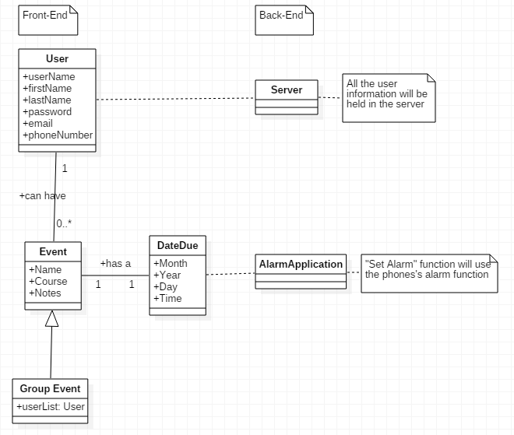

**Mock-Up User Interface**

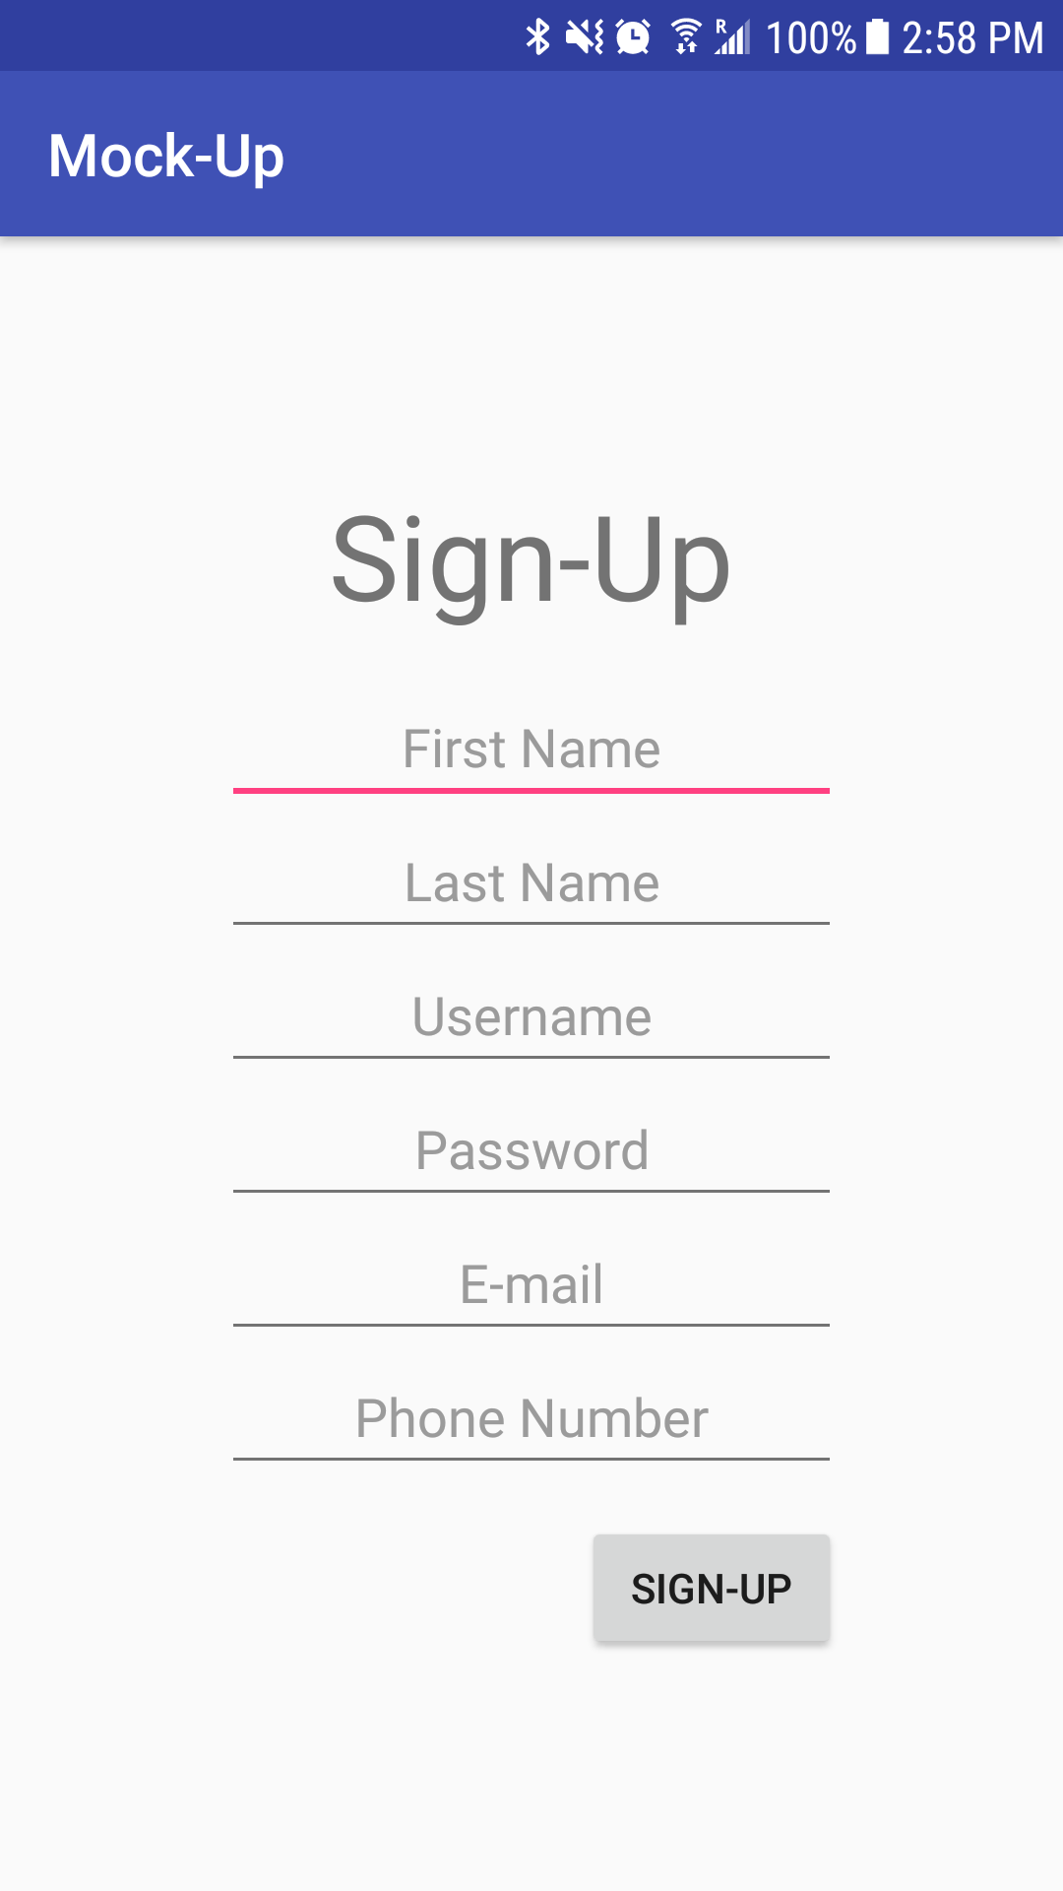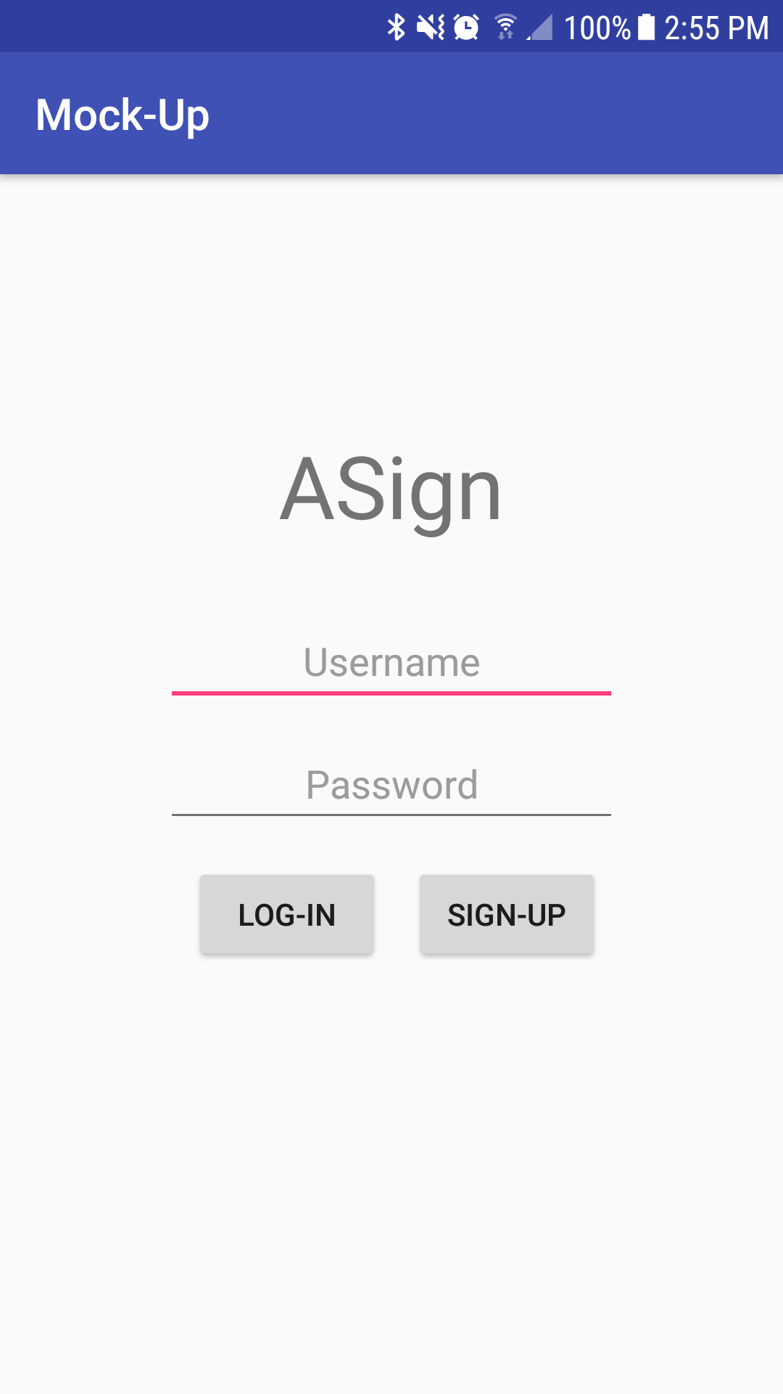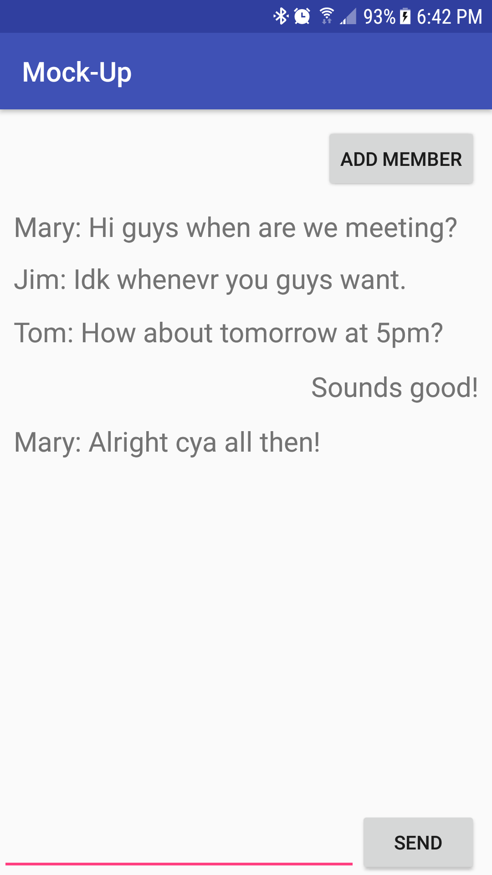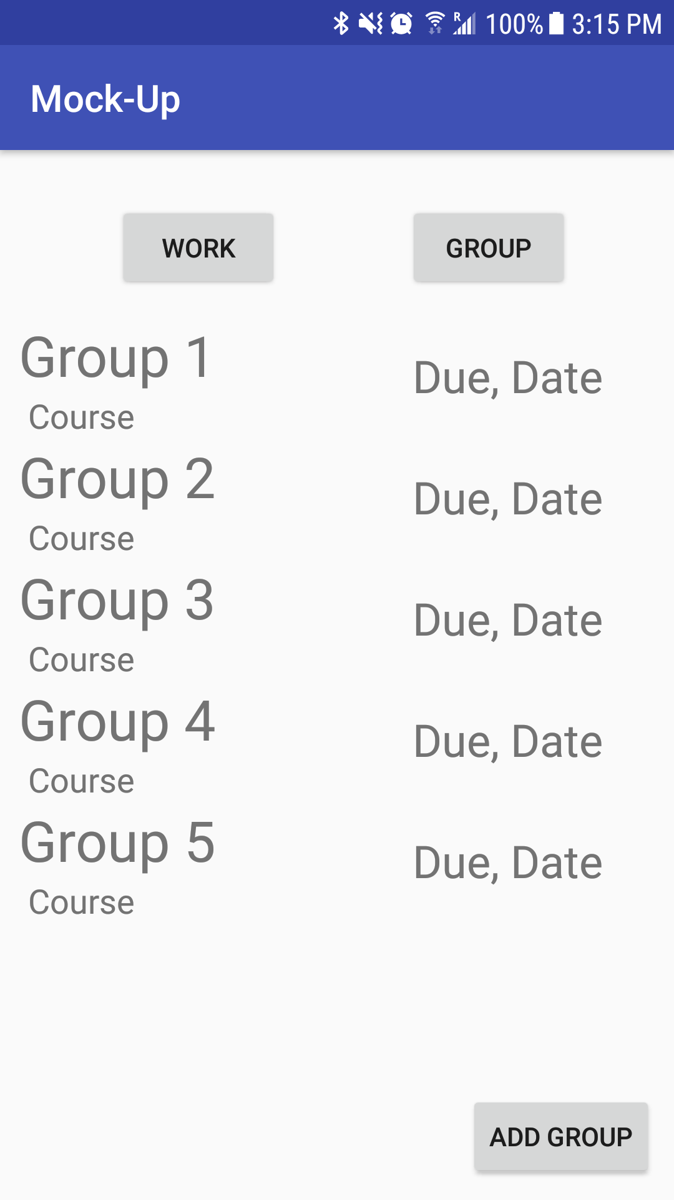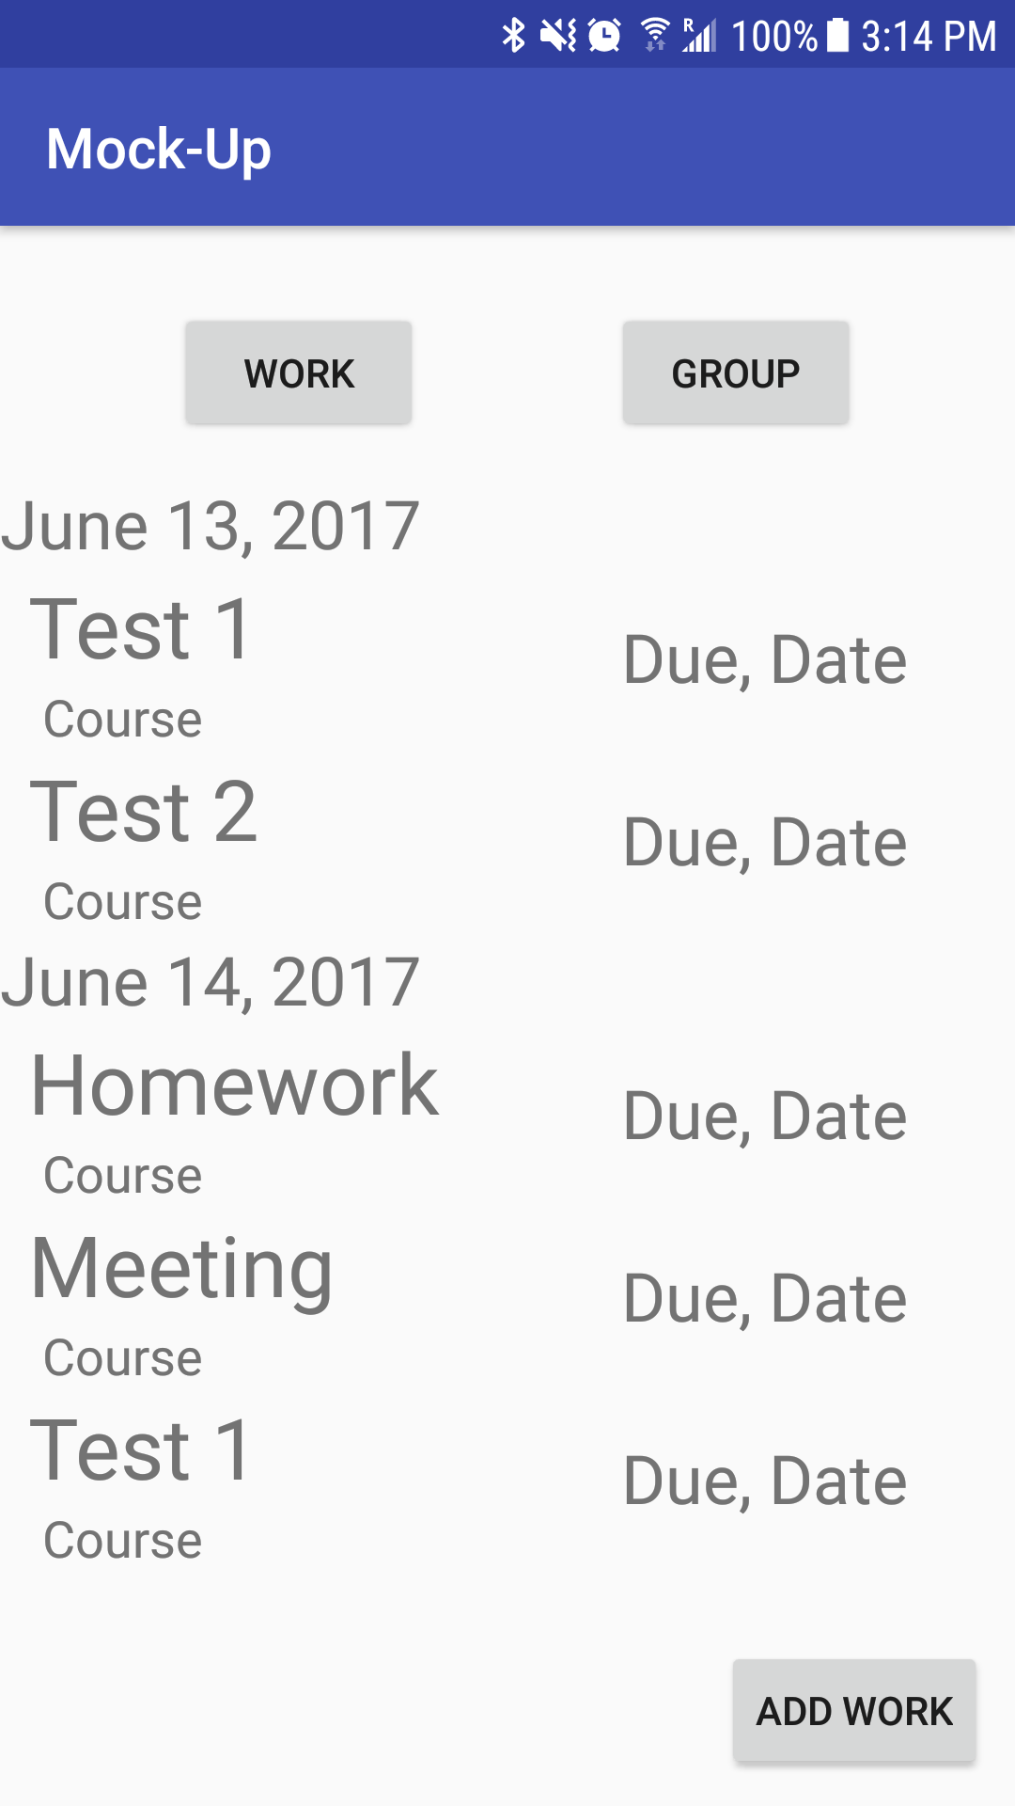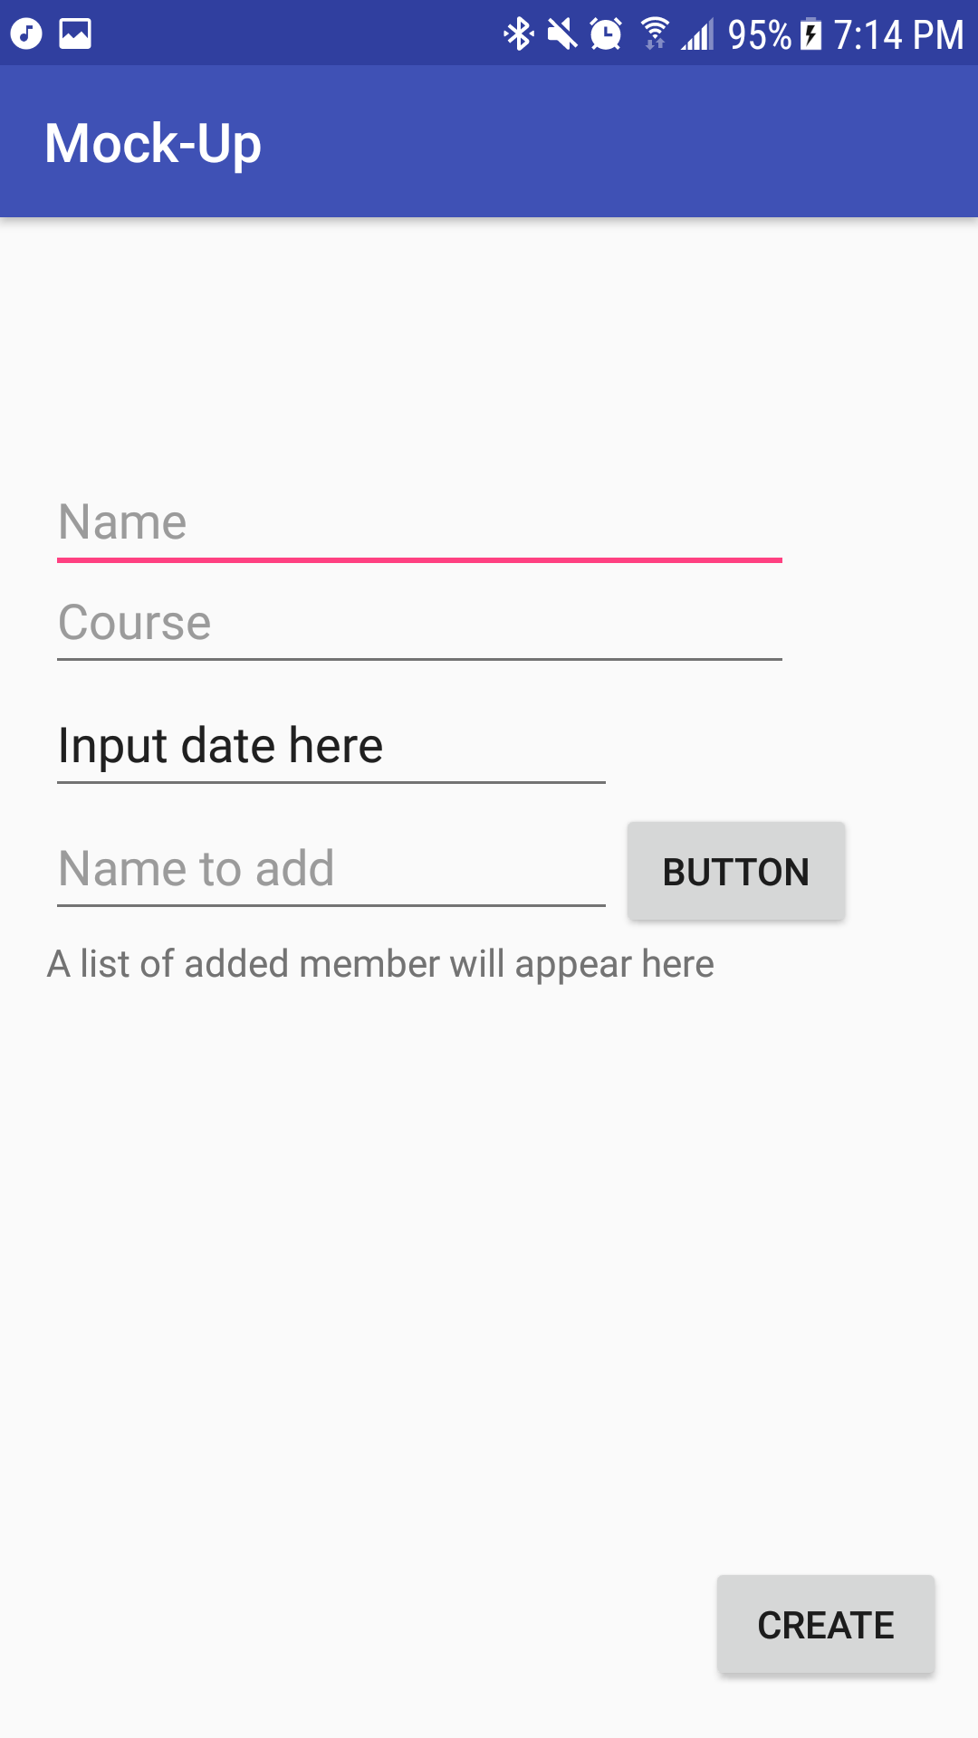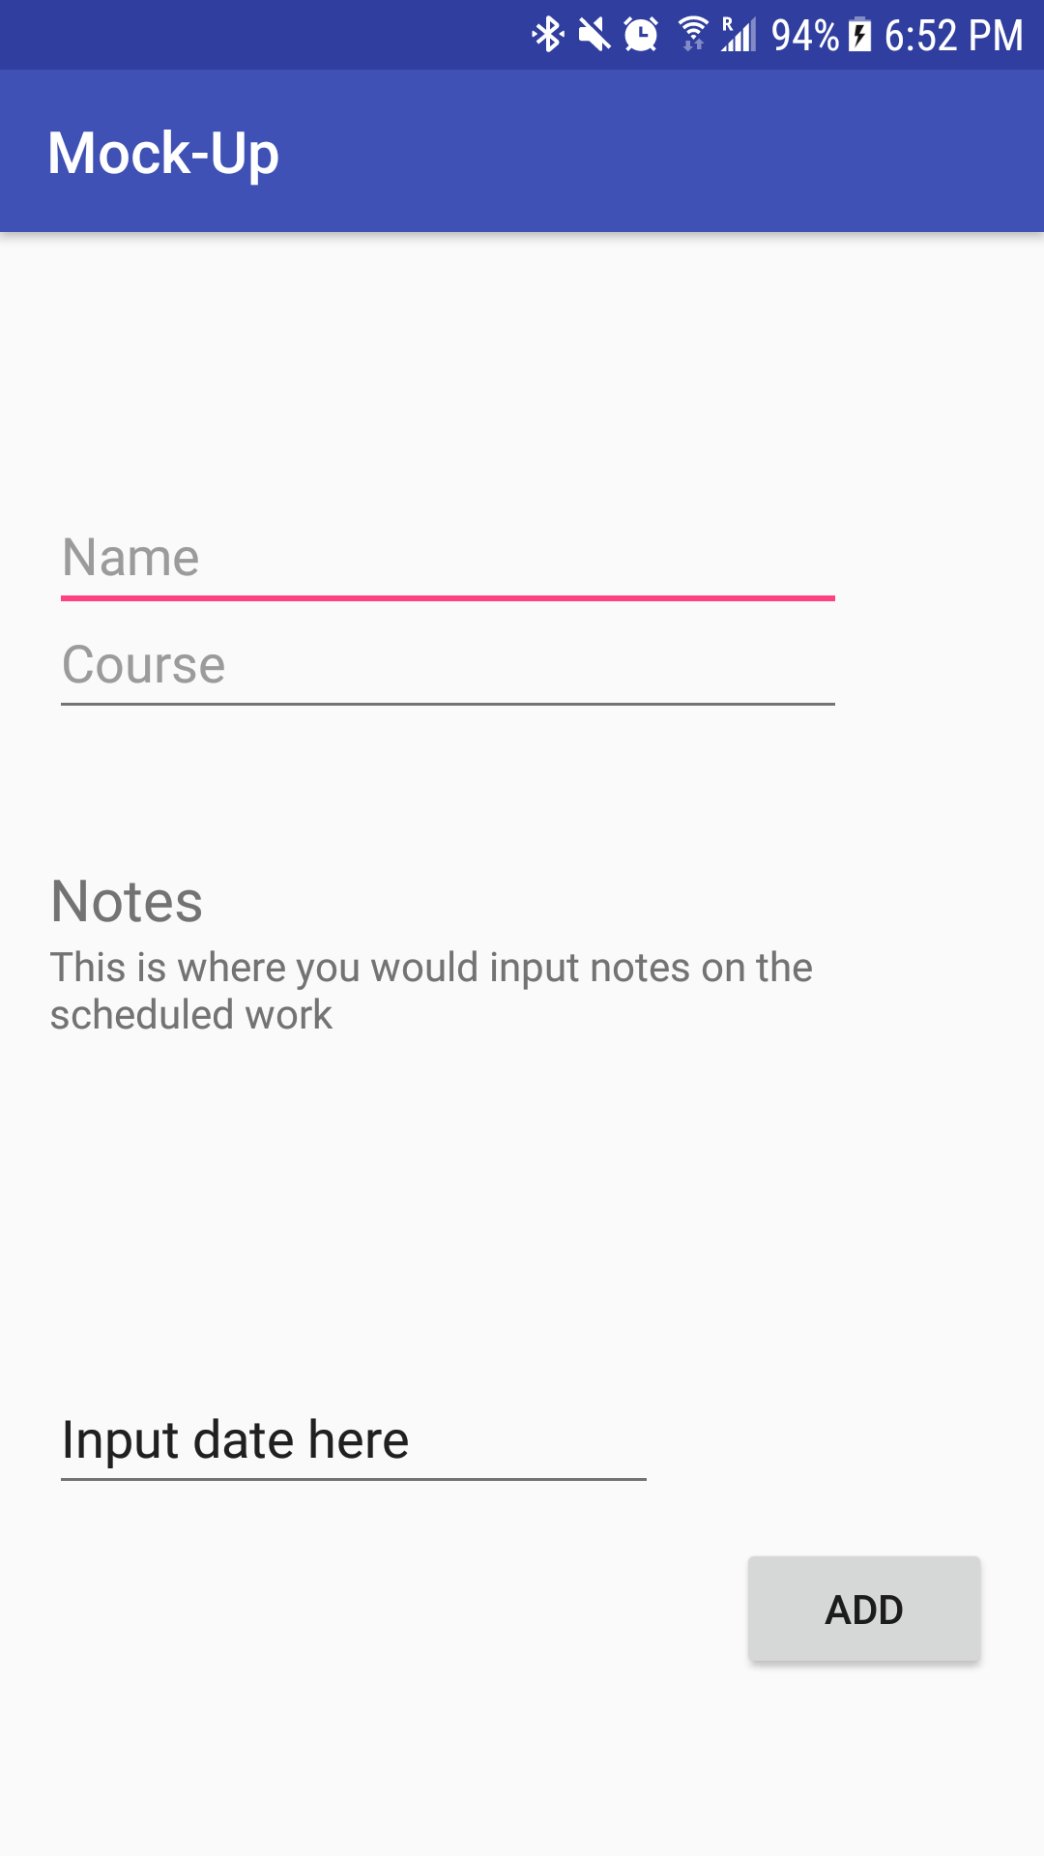

**UI Content**

All requests to go back a page would be handled by the “back” button that is built into the Android Operating System.

**Error Handling**

All user errors will be handled by a pop up Toast message.

**Essential/Core Features**

* Create a scheduled upcoming assignment
* Create a group for an upcoming group assignment
* Chat between members in a group assignment
* Sign-In and Registration functionality
* Add/Remove a member from an existing group

**Additional Features**

* Notification on upcoming assignments
* Automatic alarm tied to important assignments

**Testing**

Most testing will be done by myself. I will also use my close network of friends to find any bugs I miss. As we learn new features in class I will develop and test ASign accordingly! I will strictly only allow students to be testers so I can get the most suitable feedbackpossible.